Version Number:

Team Members :

Team No:

Module: Model Based System Engineering



./

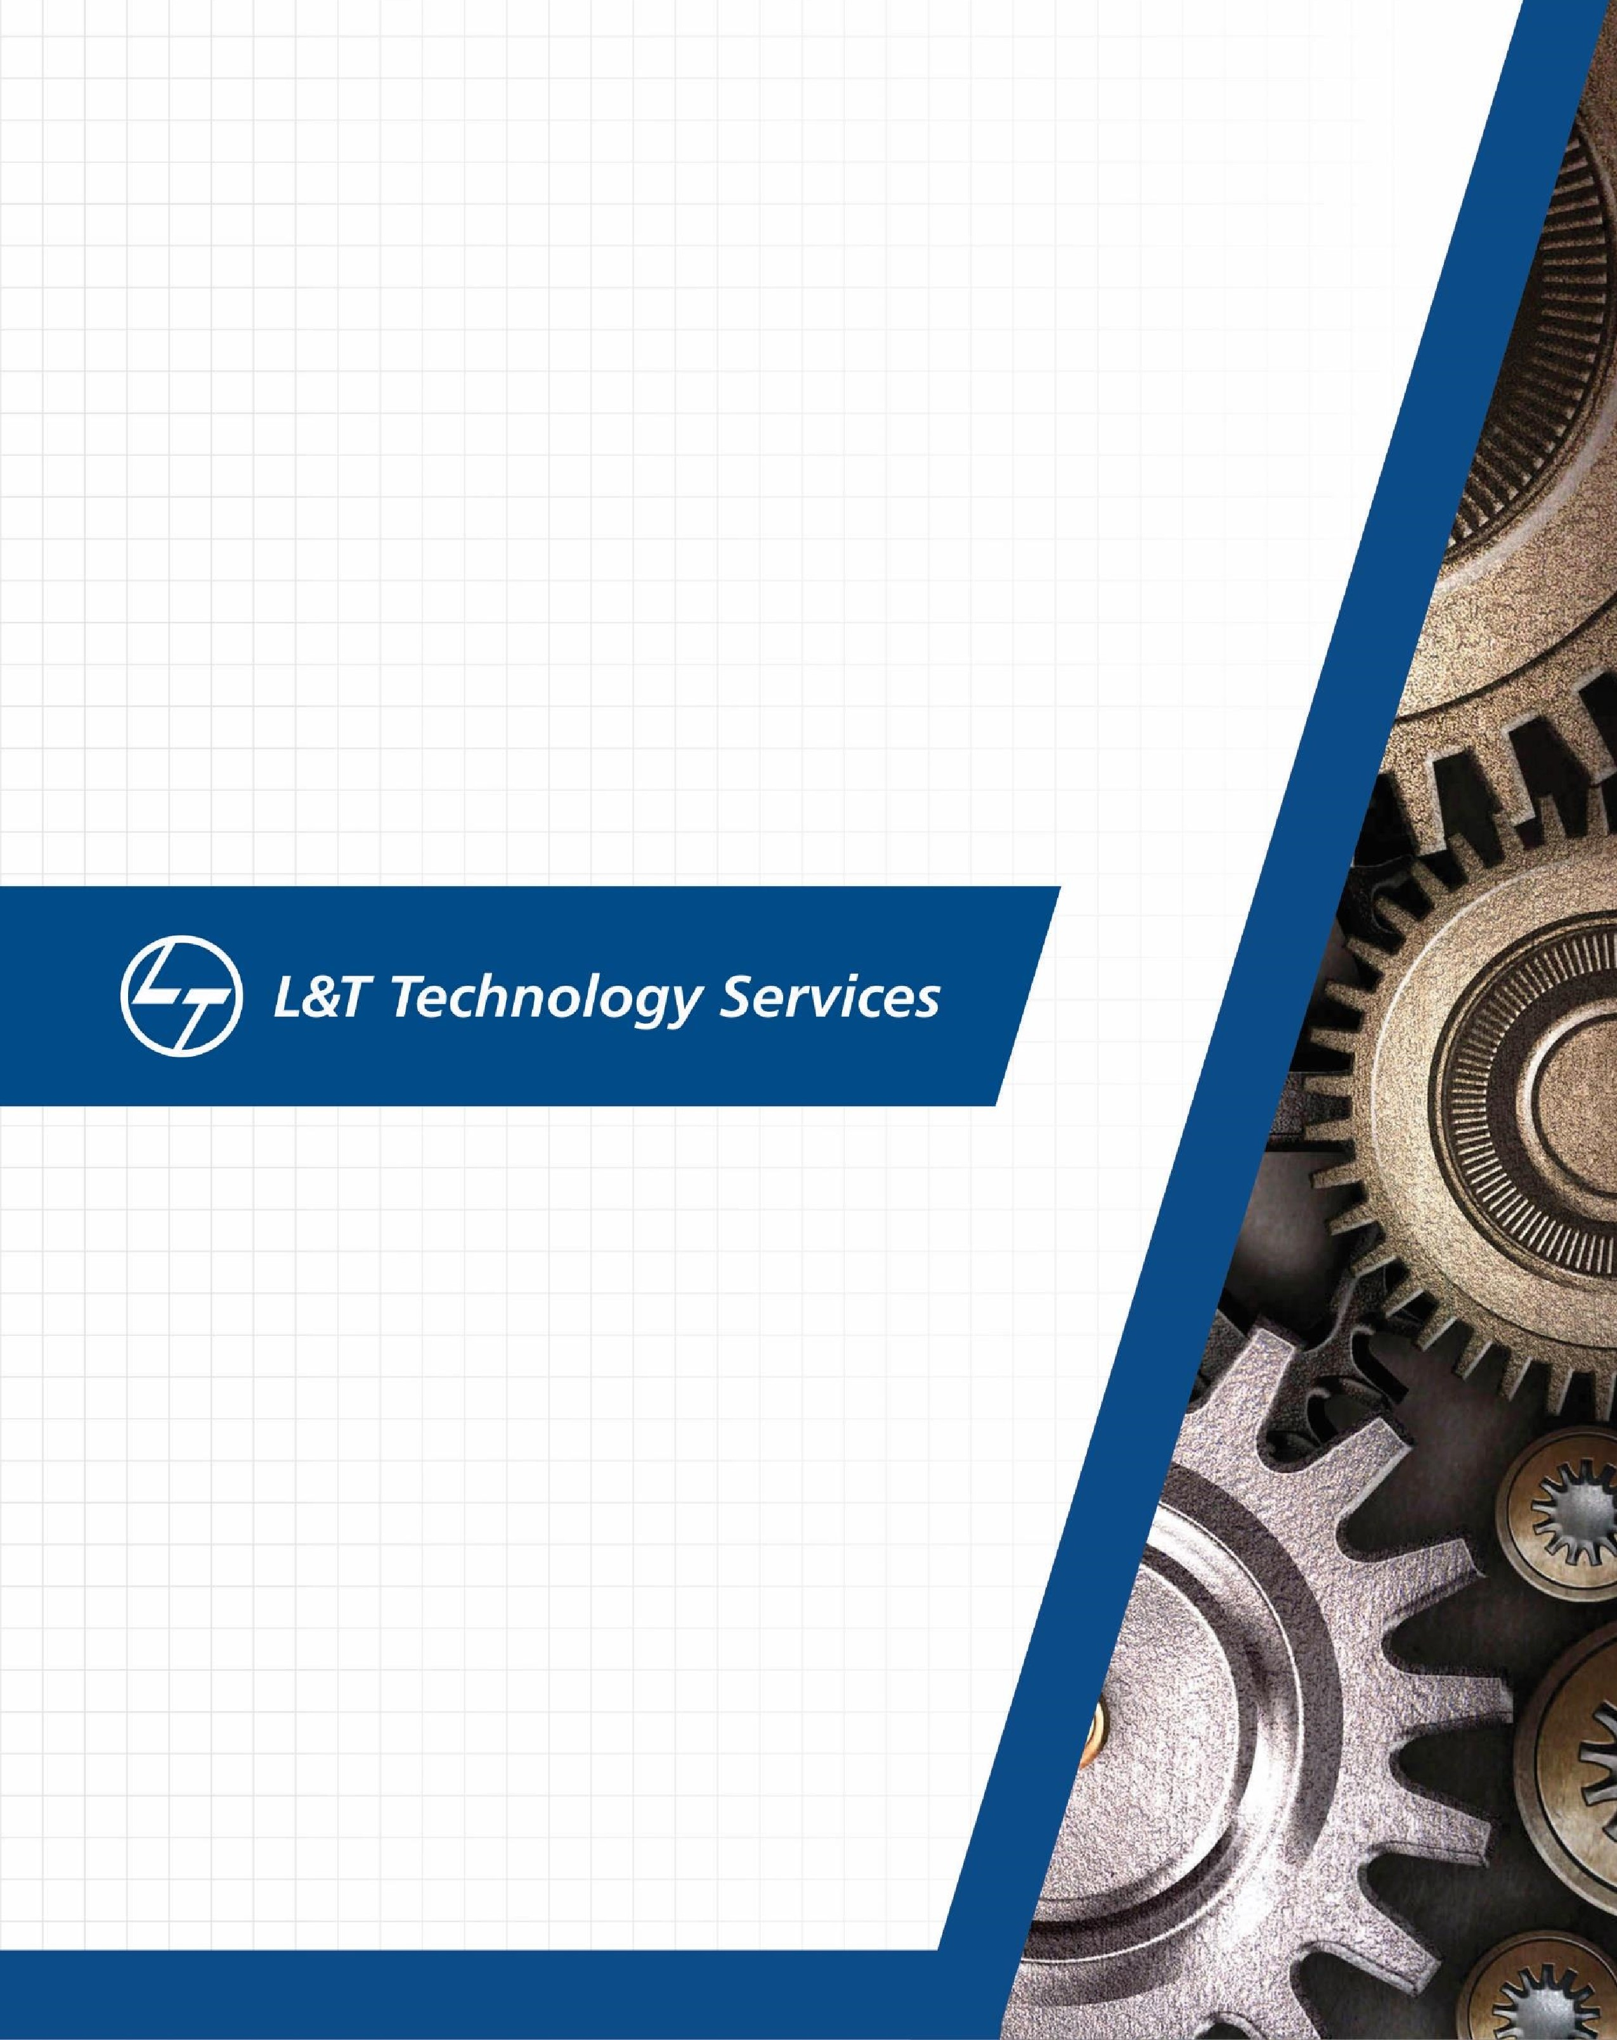

Learning Report

–

NETWORKING

**Document History**

|  |  |  |  |  |  |
| --- | --- | --- | --- | --- | --- |
| **Ver. Rel. No.** | **Release Date** | **Prepared. By** | **Reviewed By** | **Approved By** | **Remarks/Revision Details** |
|  | 09/03/2021 | Yadala Venkata Sravan Kumar |  |  |  |

**Contents**

**ACTIVITY 1** – COMPILATION APPROACH…………………………………………………………………………………………………………….. 4

1.1- MAKE FILE ................................................................................................. 4

1.2- STARTUP CODE……………………………………………………………………………………………………………………… 5

1.3- LINKER FILE……………………………………………………………………………………………………………………………. 8 1.4- DEBUGGING TECHNIQUES……………………………………………………………………………………………………………… 9

**ACTIVITY 2** – IMPLEMENTATION OF PROTOCOLS USING STM IDE ........................................................................ 10

2.1 GPIO……………………………………………………………………………………………………………………………………………………10

2.2 EXTI……………………………………………………………………………………………………………………………………………………. .12 2.3 ADC……………………………………………………………………………………………………………………………………………………...14 2.4 SPI………………………………………………………………………………………………………………………………………………………..16 2.5 UART……………………………………………………………………………………………………………………………………………………19

**ACTIVITY 3** – PROJECT ON BCM MODULE .......................................................................................................... 21

<https://www.itrelease.com/2018/07/advantages-and-disadvantages-of-wide-area-network-wan/ad>

<https://www.slideshare.net/stevencahill/networking-standards-and-protocols?next_slideshow=1>

TYPES OF NETWORKS: (PAN)

1.Personal area network:

* + personal area network is a type of network it will enables the communication between devices which are nearby (up to 100 meters)
  + PANS can be used for communicating among the personal devices themselves for connecting high level network and internet
  + examples where we used it commonly are computers, smart phones, tablets (where speed is 1-3 Mega bytes per second)
  + Another part of PAN is also present where it is called “WIRELESS PAN”
  + Examples where we use wireless PAN are wireless USB, Bluetooth

2.LOCAL AREA NETWORK: (LAN)

* LAN is a connection of group of devices that communicates happens through a common communication line or through wireless link
* There are two types of LANS (wired and wireless)
* Wired LANS uses switches, ethernet cables and servers
* For small businesses with a less no of devices we can use LAN consisting of single LAN and with enough ethernet ports to connect all devices
* Speed I this LAN is 10-100 Mega bytes per second

3.CAMPUS AREA NETWORK: (CAN)

* CAN is larger than LAN but smaller than MAN
* These types pf networks are typically seen in universities with multiple buildings in specifies area
* Most of all CANs are connected by several lans via switches and routers to create a single network
* Two primary benefits of CAN are security and speed
* Since data transfer is over a local network the speed is higher than typical internet speed

4.METROPOLITAN AREA NETWORK: (MAN)

* MAN is a network that connects users with computer resources within a geographical location
* The term MAN is interconnection of LANs in a city into a single area network and offering efficient network to a wide range of network
* Advantages of MAN are high speed than LAN,high speed and less expensive
* Disadvantages of MAN are hacker attack is higher due than LAN, so data can be secured only if high trained staff is present
* Speed of MAN is 5-10 M bps

5.WIRED AREA NETWORK: (WAN)

* In earlier the protocol used for WAN are packet-switching exchanges
* Later different protocols came into an existence like TCP/IP, ROUTER, OVERLAY NETWORK, PACKET OVER SONET, MULTIPROTOCOL LABEL SWITCHING, FRAME REALY, ATM…
* WAN is made with the combinations of **LAN** and **MAN.**
* The transmission of data is carried out with the help of hubs, switches, fiber optics, modem, and routers.
* Examples of wired area network are school area network, Internet used in it office
* Advantages of wired area network are it covers a large area of 1000 km, if your office is in different countries then you connect through office branches by WAN
* Speed of WAN is 10-20 M bps

TYPES OF TOPOLOGIES:

* MESH TOPOLOGY
* STAR TOPOLOGY
* BUS TOPOLOGY
* RING TOPOLOGY
* HYBRID TOPOLOGY

1.MESH TOPOLOGY:

* In Mesh Topology, each device is connected to every other device on the network through a dedicated point-to-point link.
* Dedicated link means it only carries data between only two devices
* Advantages of mesh topology are no traffic data between two devices
* If any link is failed that will not disturb another link so it is very reliable
* It is also very secured because any other devices cannot access the any another link, Error detection is very easy
* The disadvantage in mesh was amount of wires required to connected each system is headache.

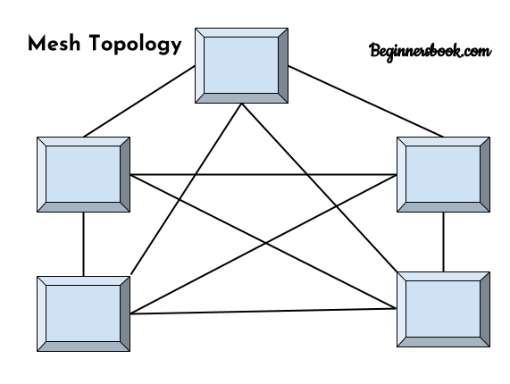

2. STAR TOPOLOGY:

* In star topology each device in the network is connected to a central device called hub.
* star topology will not allow direct communication between devices, a device must have to communicate through hub.
* The main advantages of star network is that any one malfunctioning will not disturbs the other networks
* The star topology is similar to bus topology where hub is connected to backbone of the bus, called as an tree
* The advantage of an star topology was any devices can be added or removed without disturbing others
* It also will works under heavy load

STAR TOPOLOGY NETWORK

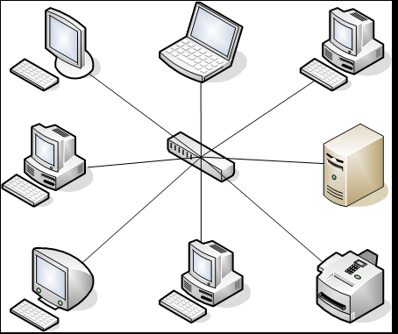

3.BUS TOPOLOGY:

* It is also called as line topology
* It is an network where every computers are connected to a single cable called backbone
* Cable might be coaxial cable or RJ-45 for connecting together
* The advantages of an bus topology are it requires less cable lengths than star topology
* For small network devices it will work well
* The disadvantages of bus topology are identifying the problem in complete network
* One error will disturbs the total damage of network

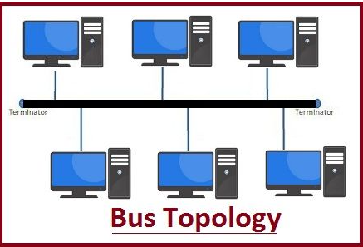

4.RING TOPOLOGY:

* In ring topology the network is connected in a circular path
* In this each device is connected to two other devices
* In this collision of data will not happen because of token system
* Each node or device release data once the token is received
* Performance is better than bus topology in traffic of data
* In this there is equal access for all devices

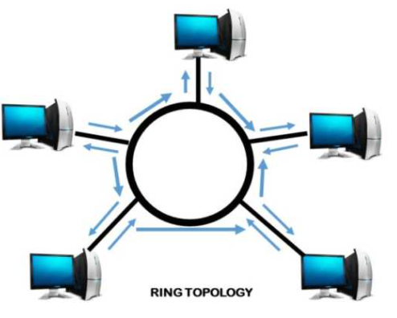

5.HYBRID TOPOLOGY:

* This is a type of topology where it uses two or more different networking topologies
* Mostly used topologies in this are star-ring and star-bus hybrid topologies
* The advantage of hybrid topology were error detection and troubleshooting is easy
* Handling of large volume traffic is an major advantage in large networks
* The disadvantages of this are highly expensive
* Designing task is also an complex task
* Hubs are required to connect two different networks
* Installation is also an difficult task

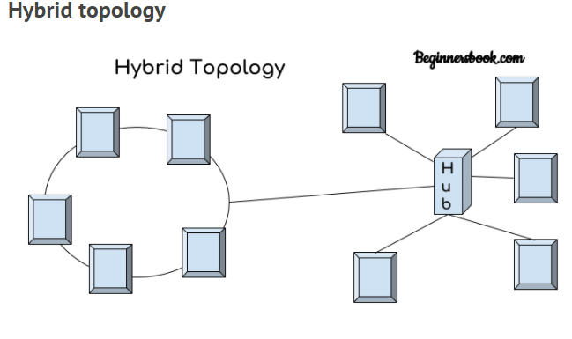

WIRED AND WIRELESS NETWORKS:

1. WIRED NETWORK

* Wired networks also called ethernet networks are the most common type of local area network
* It is simply a collection of two or more devices by ethernet cables
* Ethernet is the fastest wired network protocol with 10-100 mbps
* There are three network topologies which are used by
* Bus topology
* Star topology
* Ring topology

1. WIRELESS NETWORK

* A wireless network uses high frequency radio waves than wires to communicate
* The three types of wireless networks are
* **wireless LANs**
* **wireless MANs**
* **wireless WANs**

## Advantages of Wireless Networks

* It provides clutter-free desks due to the absence of wires and cables
* It increases the mobility of network devices connected to the system since the devices need not be connected to each other.
* Installation and setup of wireless networks are easier.
* New devices can be easily connected to the existing setup since they needn’t be wired to the present equipment
* Wireless networks require very limited or no wires. Thus, it reduces the equipment and setup costs

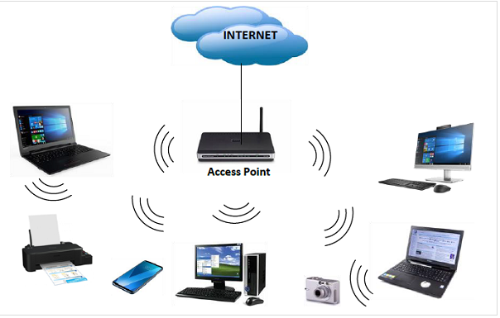

COMPONENTS IN NETWORKING:

1. Routers
2. Hub
3. Switches
4. Bridge
5. Access points

1.ROUTERS:

* A **router** is a **networking** device that forwards data packets between computer **networks**
* **Routers** perform the traffic directing functions on the Internet
* When a data packet comes in on one of the lines, the **router** reads the **network** address in the packet header to know the destination.
* The most familiar type of IP routers are home and small office routers that simply forward IP packets between the home computers and the Internet
* When multiple routers are used in interconnected networks, the routers can exchange information about destination addresses using a routing protocol
* A router has two types of network components i.e. control panel and forwarding panel
* Control plane maintains the routing table that which route should be forward data packets through physical interface connection
* Forwarding plane will forward data packets between incoming and outgoing plane

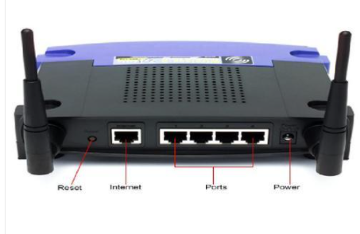

2.HUB

* A hub is a physical layer networking device which is used to connect multiple devices in a network.
* A normal hub will have many ports present in it
* A computer which needs to connect to hub will be connected through one of those ports
* When a data frame is arrived in receiver at a port it will broadcast to every port considering whether it is destined for a particular destination or not.
* They operate in the physical layer of the OSI model.
* Transmission mode is half duplex.
* Collisions may occurs during setup of transmission when more than one computers place data simultaneously in the corresponding ports
* They are passive devices, they don’t have any software associated with it.

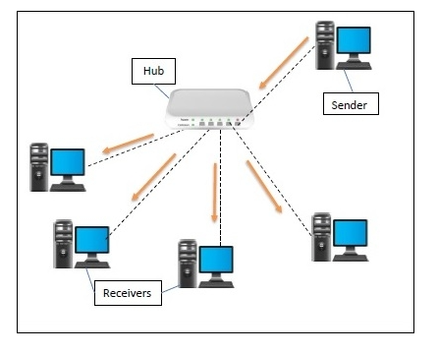

1. SWITCHES

* A switch is a data link layer networking device which connects devices in a network and uses packet switching to send and receive data over the network.
* Like a hub, a switch also has many ports, to which computers are plugged in.
* However, when a data frame arrives at any port of a network switch, it examines the destination address and sends the frame to the corresponding devices
* So, it supports unicasting and multicasting.
* They operate in the data link layer of the OSI model.
* Transmission mode is full duplex.
* Collisions do not occur since the communication is full duplex.
* The number of ports is higher – 24/48.

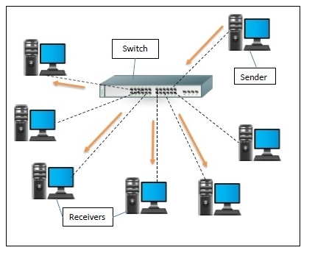

4.BRIDGE

* A bridge operates at data link layer.
* A bridge is a repeater, with add on the functionality of filtering content by reading the MAC addresses of source and destination.
* It is also used for interconnecting two LANs working on the same protocol
* It has a single input and single output port, thus making it a 2 port device.

There are two types of bridges

1.Transparent bridges

2.Source routing bridges

**1.Transparent Bridges:**

* These are the bridge in which the stations are completely unaware of the bridge’s existence i.e. whether it is a bridge is added or deleted from the network, reconfiguration of the stations is unnecessary. These bridges make use of two processes i.e. bridge forwarding and bridge learning.

2. **Source Routing Bridges:**

* In these bridges, routing operation is performed by source station and the frame specifies which route to follow. The host can discover frame by sending a special frame called discovery frame, which spreads through the entire network using all possible paths to destination.

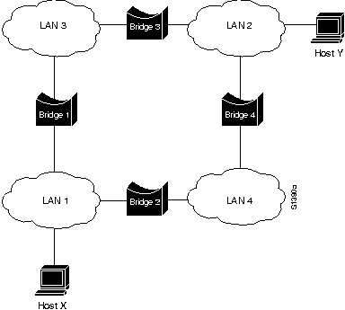

5.GATEWAYS:

* A gateway is a network node that forms a passage between two networks operating with different transmission protocols
* The most common type of gateways, the network gateway operates at layer 3
* depending upon the functionality, a gateway can operate at any of the seven layers of OSI model.
* It acts as the entry – exit point for a network since all traffic that flows across the networks should pass through the gateway.
* It forms a passage between two different networks operating with different transmission protocols.
* A gateway operates as a protocol converter, providing compatibility between the different protocols used in the two different networks
* It also stores information about the routing paths of the communicating networks.
* It uses packet switching technique to transmit data across the networks.

TYPES OF GATEWAYS:

1. **Unidirectional Gateways**

* They allow data to flow in only one direction. Changes made in the source node are replicated in the destination node, but not vice versa. They can be used as archiving tools.

2. **Bidirectional Gateways**

* They allow data to flow in both directions. They can be used as synchronization tools.